* Dioptase Project -

Documentation

The team created the program: „Dioptase“

SVN: <https://team-dioptase.googlecode.com/svn/trunk/>

1. Team members:

1) Borislav Ivanov

2) Martin Nikolov

3) Martin Marinov

4) Zheko Karpichev

5) Polya Pavlova

2. Description of the program:

Program Dioptase is a program that would be used by a movie rental company for a given amount of time and selling games and music CDs. Operating the program will be the seller himself in the store. We tried to make the interface easy to use, understandable and enjoyable.

2.1 Main window

In the main window of the program you can see the three buttons movies, music and games, which at the same time refer to the given library of items offered by the store. There are also 2 more buttons for accessing the client database and company statistics. Removed is the standard Windows framework and 2 buttons are added at the top right that have the function to close a window and minimize it.

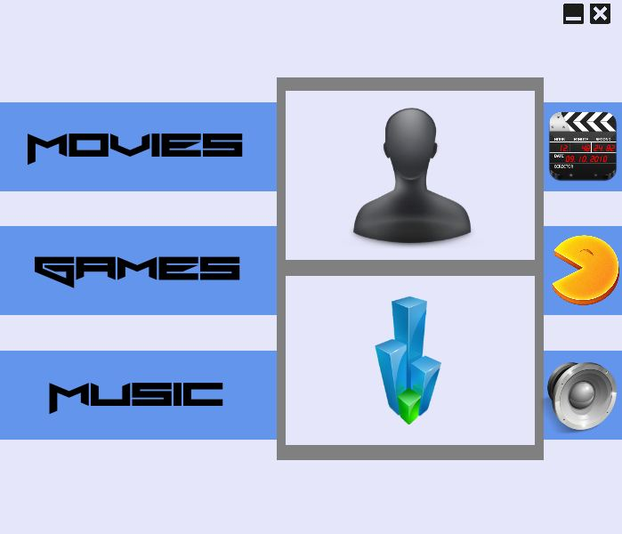

2.2 Article libraries

For all three product lines, the windows are the same with the differences that the top right icon is different and the genres are selectable. Top left is the arrow that takes us back to the main window. Much of the window itself is occupied by the visualization of all products, which is located almost centrally. Products are displayed accordingly with their cover and the name above them. Above the product preview, there is a search bar by product name. The tape also works with parts of words. The right part of the window shows the genres for the given directory. Multiple genres can be selected at a time.

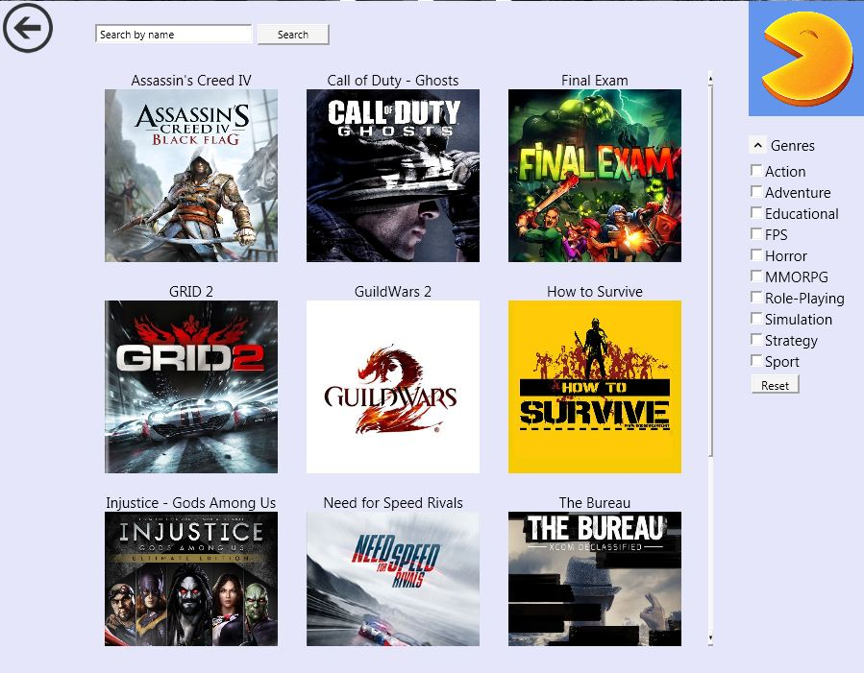

2.2.1 Window displaying detailed information about products for sale

This window displays details of the product being sold, including the cover, name, genre, year of issue, and whether it is available. The product can be purchased from this window. Also at the top of the close button the price is displayed.

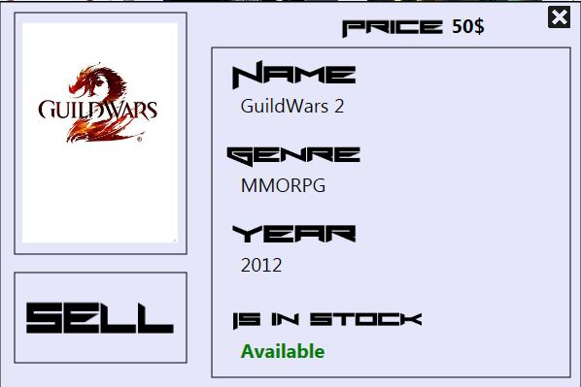

2.2.2 Window displaying detailed information on rental products

It has the same properties as the front window except that it is used in rental products.

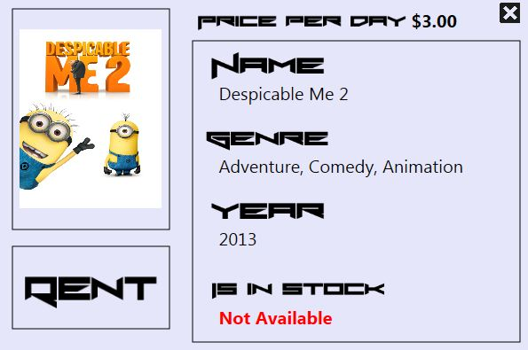

Pressing the "Rent" button gives you an additional window to choose how long the product will be rented and how much it will cost.

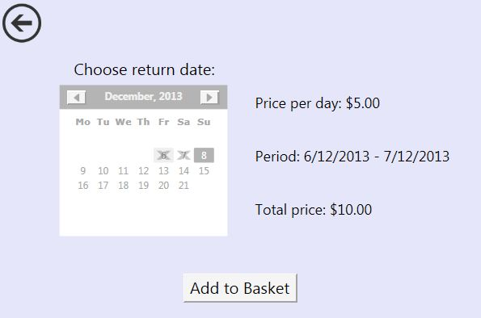

2.3 A window previewing the company's customers

Top left again shows the arrow to return to the main window. Below the arrow is the search bar. It searches for clients by name and can handle parts of names. Below the bar is a complete list of all clients' names. Only their names are displayed. Below the customer list are all the products that have been selected and added to the basket, and accordingly, when choosing a customer, the basket can be closed and the desired products can be paid. In the center and bottom right there is a field with full information about the client. This field displays the customer's picture, names, years, phone number and address.

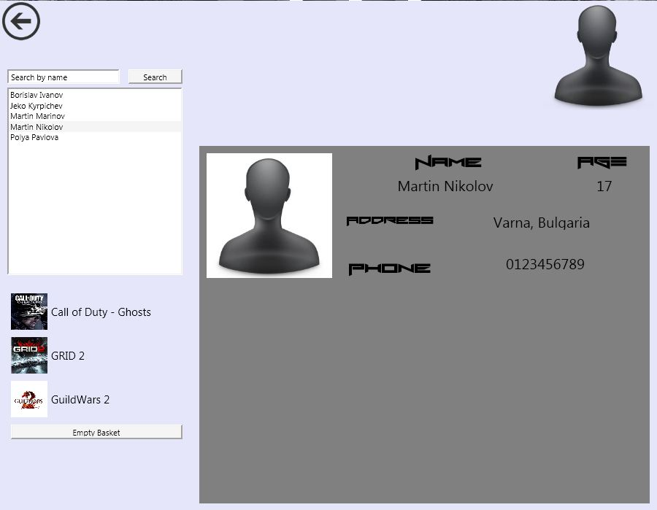

2.4 The Statistics window

The statistics window displays the number of items rented or sold and the total amount of money they brought.

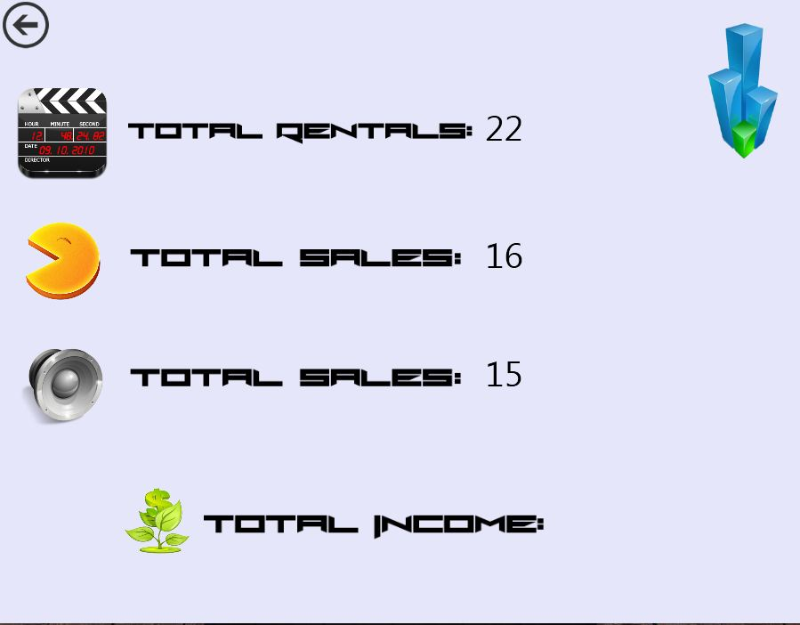

3. Class Diagram

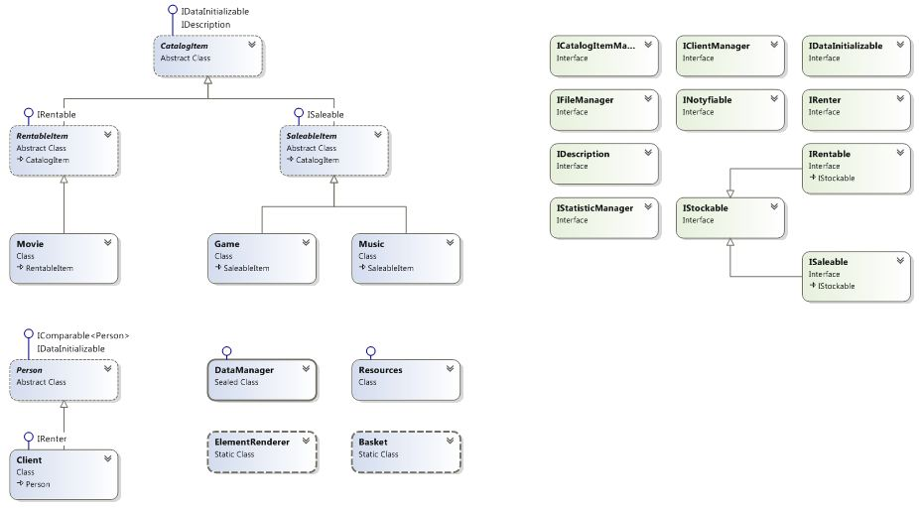

4. MindMap

